Putative Father Registry & Search

Application User Guide
DCBS Internal
Version 1.0

Prepared For:
Department for Community Based Service
Cabinet for Health & Family Services

Prepared By:
Health Services Systems Management Branch
Division of Social Support Services
Office of Application Technology Services
Cabinet for Health and Family Services
Contents
1. Purpose of the Document 4
2. User roles, site and Credentials 4
2.1. Office of DCBS 4
2.1.1. Navigating the KOG system 4
2.1.2. Password Resets & Recovery 6

3. DCBS Worker 6
3.1. Landing Page 6
3.2. Search 6
3.3. Post submission 8
3.4. Update 8
3.5. Clone 8
3.6. Select a status 9
3.7. Free Text search 9
3.8. Column Sort 9

Purpose of the Document
This User Guide is intended as an aid for business users to log-in as DCBS Worker or DCBS Admin into the Production environment of Putative Father Registry & Search Application using the Kentucky Online Gateway (KOG).
The KOG is the single sign on portal for the Commonwealth of Kentucky. Each user of the application will need to have a KOG account. When logged in, the control will take the user to launching and landing page.

User roles, site and Credentials
# | Access | DCBS Worker | DCBS Admin
1 | Registration |  | Enter/Update/Deny/Reject/Approve
2 | Search | Request/Print | Request/Update/Approve
3 | Reports |  | All

Following internet browsers can be used to launch the application:
  - Google Chrome
  - Internet Explorer
  - Microsoft Edge

Production URL: https://kog.chfs.ky.gov/home/

Office of DCBS

Navigating the KOG system
- Step 1:
Copy and paste the URL on any of the browsers listed in Section 2 and press enter, following screen shows up.
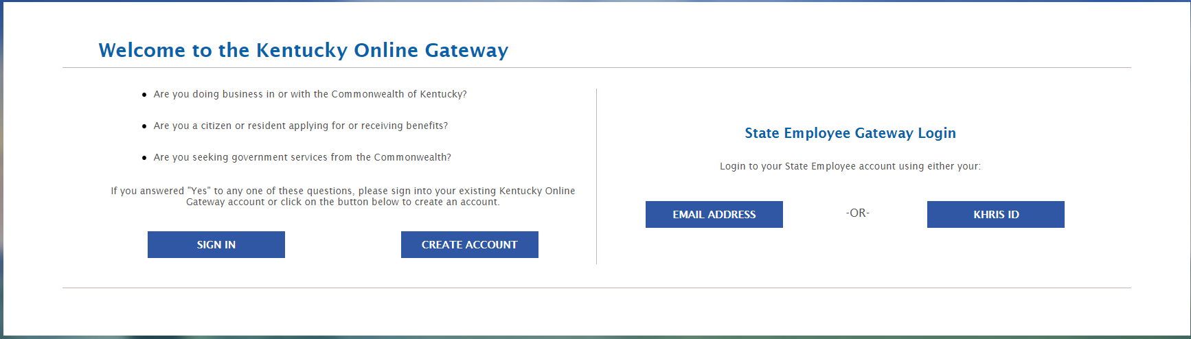
- Step 2:
Click the “Email Address” located under “State Employee Gateway Login” on the right.
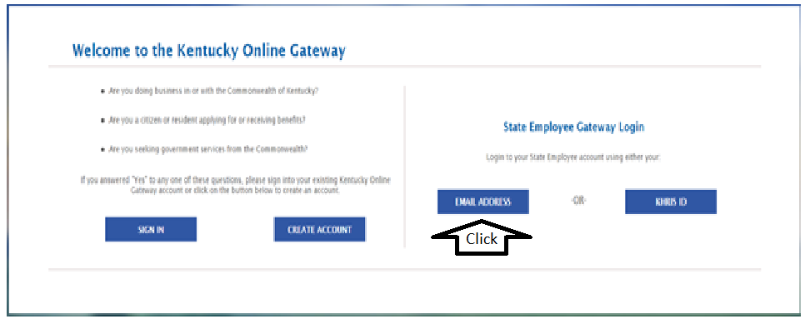
- Step 3:
Users should see following screen and now required to enter the user-id and password information as provided for DCBS Worker role.
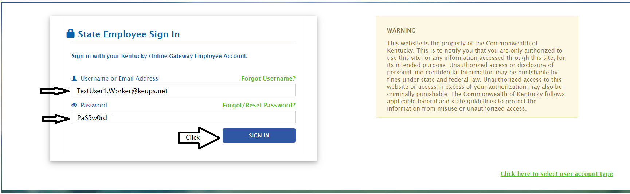
- Step 4:
The control reaches “My Apps” screen. Click the “Launch” tab.
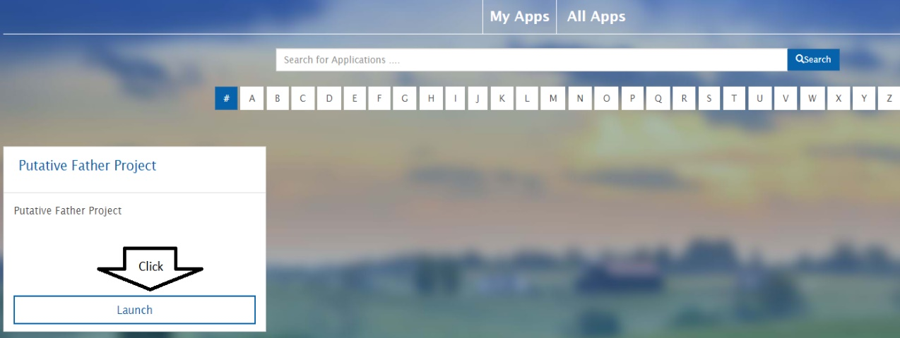

- Step 5:
Now the user will see the Landing Page of the application for DCBS Worker role.
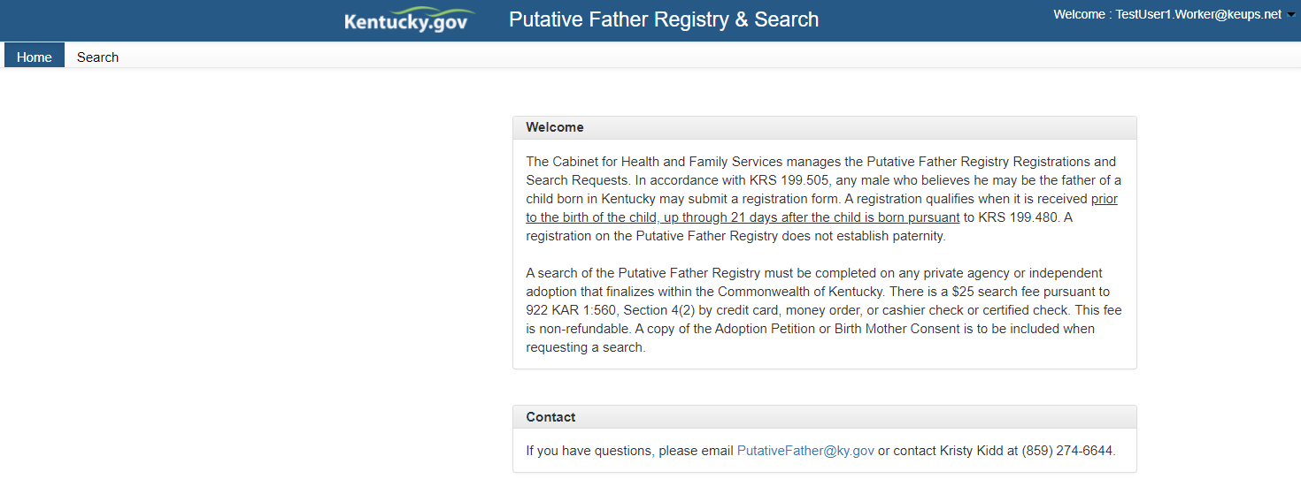

Password Resets & Recovery
KOG passwords will expire after ninety (90) days. There are two ways to reset the password.

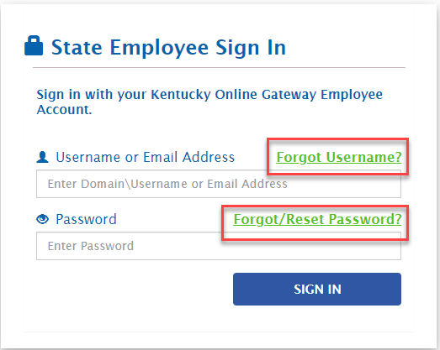
- Option 1:
Click FORGOT USERNAME and provide the email address for User name recovery. In case one do not recall your email address or have no access to the email account, please contact KOGHelpDesk@ ky.gov for assistance.
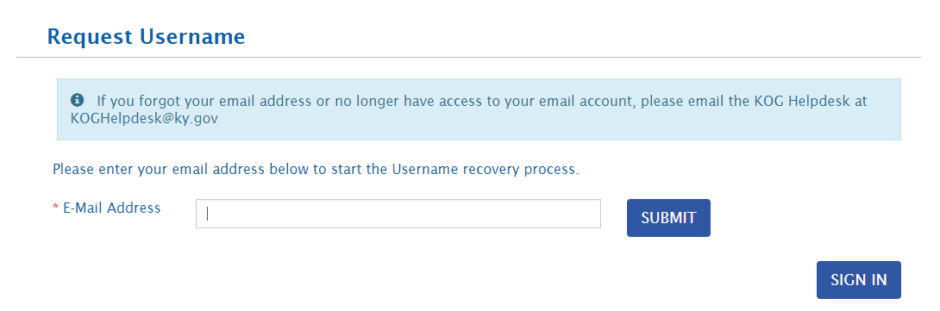
- Option 2:
Click “Forgot/Reset Password?” and provide the Mobile or E-mail address or Employee ID (KHRIS) and will receive a notification with a link to reset the password.

*Note: If you have verified your mobile number with KOG, then only use “Reset Password via Mobile or Employee ID (KHRIS)” option.
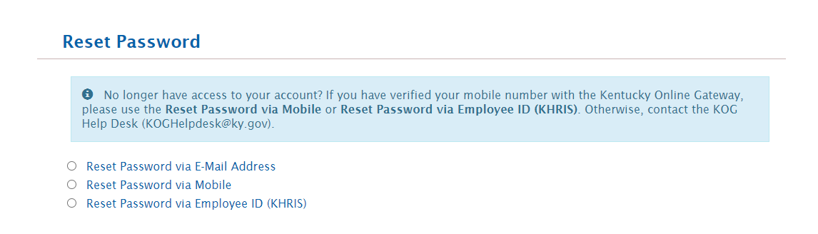

DCBS Worker

Landing Page
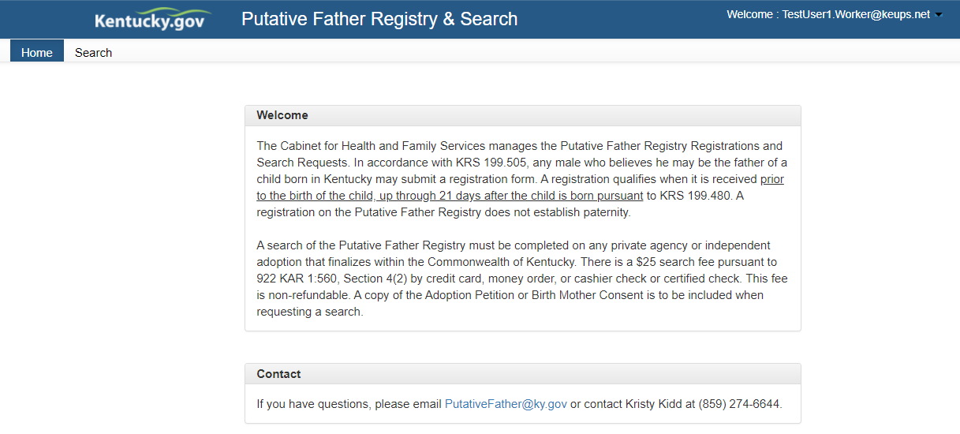

Search
When Search tab is selected the grid below will display all the Search requests that the logged user has saved or submitted till date. When logged in for the first time, the grid will not display any entry.

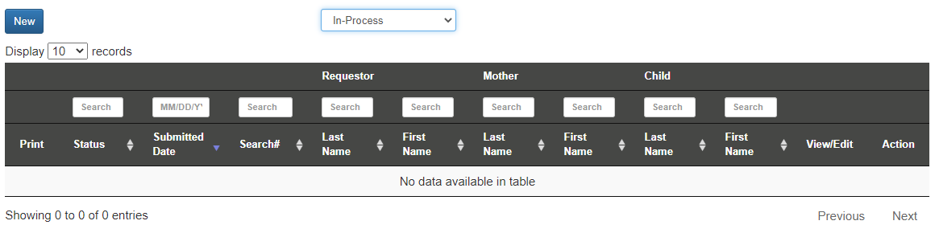
DCBS Worker can generate a search request. By clicking “New” tab, a search request form will open up. User should now enter all relevant information in sections of the search form.
      - Requester Information
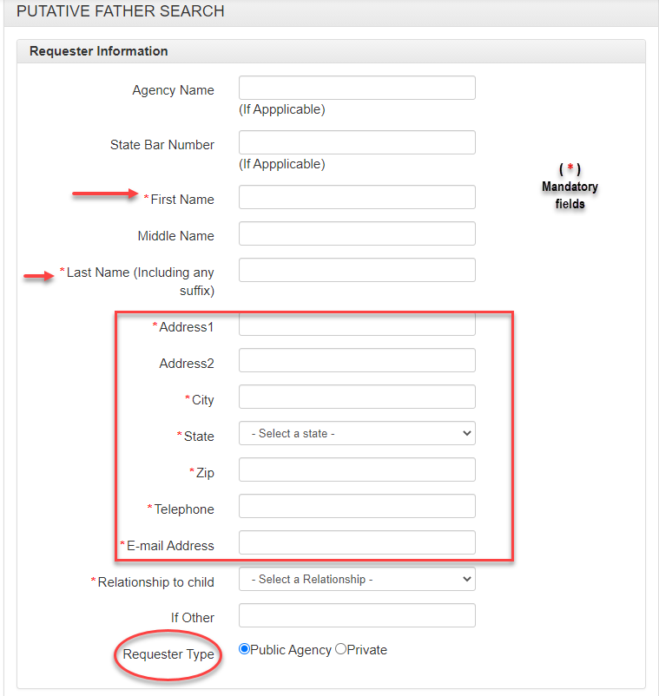
      - Birth Mother Information

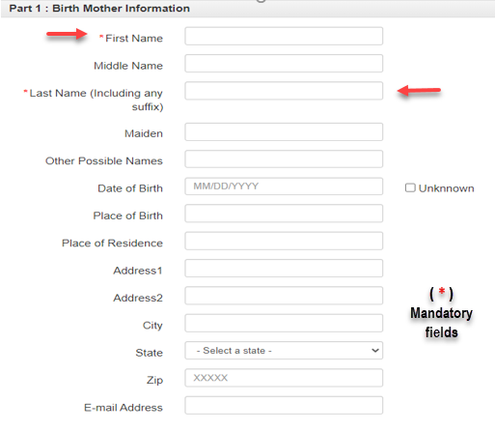

      - Child Information

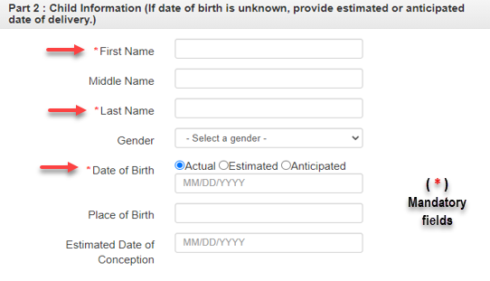
      - View/Upload Documents
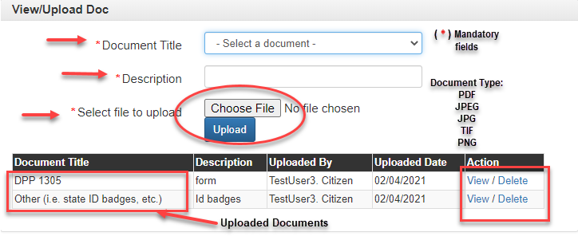
Last section of the Registration Form requires DCBS Admin to upload documents by selecting value from the dropdown, to identify the type document being uploaded. [The fields marked with asterisk are mandatory only if the user decides to upload any supporting document.] Based on the selection, user has to fill up “Description” field in support of the document to be uploaded. All the fields of this section are mandatory. Once a document is uploaded, it will be displayed on grid. User will have an option to View or Delete the document, if required. The system will display non-editable fields that shows the status, name of DCBS Staff and submission date.

Accepted Documents: -
- Birth Mother Consent
- Adoption Petition
- DPP 1305
- Affidavit (After notarized)
- Other (i.e. state ID badges, etc.)
Supported Format:-
- PDF
- JPEG
- JPG
- TIF
- PNG

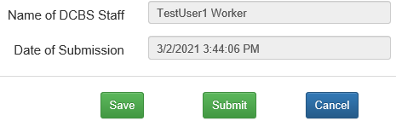

The system will generate non-editable fields that record the name of DCBS Staff and submission date.

Note - Before clicking the “Submit” button, DCBS worker should ensure to fill up all the fields marked with (*) since they are mandatory and required to proceed with registration.
Additional Guidelines:
- Agency Name is used for the attorney or adoption agency & State Bar Number is for the attorney or Law firm to fill in.
- First, Last, Name, Address etc. are the contact information of the person who is initiating the Search.
- Date Fields have date picker/calendar option.
- Date of Birth for Mother cannot be in future.
- Date of Birth for Mother is optional. If not entered, user will be forced to check the check box “Unknown”.
- State and Gender field can be selected from drop down.
- Zip code should be numeric.
- Email address should contain at least a ‘@’ sign.
- All other fields will accept alphabets and numeric characters.
- Fields highlighted with grey are non-editable and will be populated by the system.
- Requestor can complete the search request by clicking the “Submit” tab.

Post submission
  - Once the request is submitted and a Search# is assigned. The assigned Search# will be displayed on the grid against the entry.
  - A system will generate email notification from putativefather@ky.gov to the requestor and DCBS Administrator upon receipt of a new Putative Father Search request.

Update
By clicking “Update” against an existing entry, a Requestor can update and submit an incomplete entry.
Update screen similar to new screen except for the previously entered and saved value are displayed for any further edit.

Clone
By clicking “Clone” option on display grid, it will allow the requestor to replicate an existing entry and when clicked, the newly created entry will have the status as “Saved”. They can click “Update” to change the content as necessary.

Select a status
If the requestor has too many records with different status, such as Submitted, Approved< Denied, In-Process etc., the option on the top will allow the requestor to filter the requests by Status. Statuses are available on “Select a Status” drop down as shown in screenshot below.

Free Text search
On each column on the grid, there will be text box, where a user can enter text to search status, submission date, registration number, last/middle/first name etc. The system will isolate those records that meet the Search criteria and display them. This functionality is useful when one has too many records on the grid and looking for a particular entry.

Column Sort
The up & down arrow on each column on the grid indicates that the values on those columns can be sorted in ascending or descending order. Not all the columns will have the functionality due to data type & content.

